**A Brief History of Manchester's Railways**

**Liverpool and Manchester Railway**

The railway that offered the first steam-powered passenger carrying service to and from Manchester was also the first steam-powered passenger carrying railway service in the world - the Liverpool and Manchester Railway, 31 miles long and opened in September 1830. This was George Stephenson's famous line across what many thought to be an impenetrable barrier - Chat Moss - between Newton and Eccles. The creation of a stable track-bed across this treacherous area of deep [peat bog](https://en.wikipedia.org/wiki/peat_bog) was one of the most difficult challenges faced by the constructors of the line.

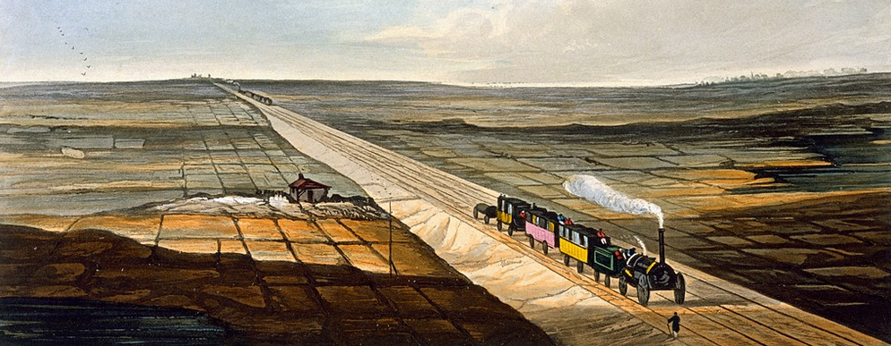

View of the railway across Chat Moss by TT Bury (public domain).

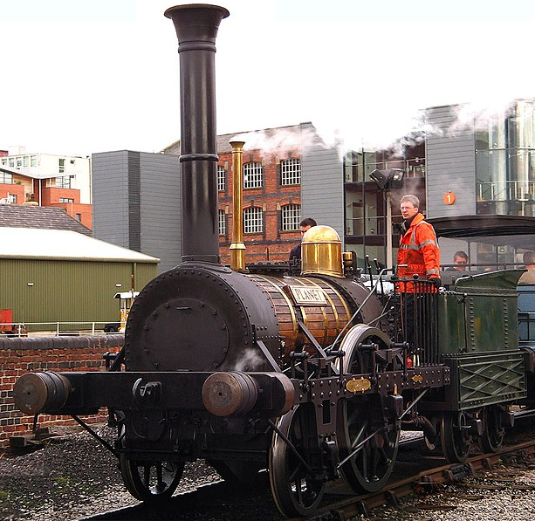

A working replica of Robert Stephenson's 1830 locomotive Planet, the ninth locomotive built for the L&MR, it was Stephenson's next major design change after the Rocket. On 23 November 1830 No.9 Planet ran the approximately 50 km (30 mi) from Liverpool to Manchester in one hour. The photograph has been released into the public domain by its author, G-Man (https://www.g-man.net/)

The line is still in heavy daily use and appears in the simulation from Liverpool Link running through Patricroft and Eccles before reaching Salford and Manchester.

The original Manchester terminus was on Liverpool Road, now incorporated into the Museum of Science and Industry (MOSI) in Manchester. In 1844 Liverpool Road station was closed for passenger traffic, which was instead taken on an extended line into what was then a new station at Manchester Victoria. The link to Piccadilly (then known as London Road) was constructed by the Manchester South Junction and Altrincham Railway (MSJ&AR) in 1849 via its main Manchester station at Oxford Road. At London Road the MSJ&AR used a single platform to the south of the main terminus which was the predecessor of the current through platforms 13 and 14.

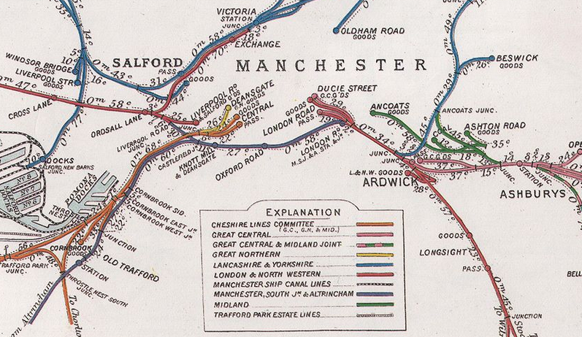

A 1910 Railway Clearing House map of central Manchester showing the links between the old Liverpool Road terminus of the Liverpool and Manchester Railway, Manchester Victoria, Manchester Oxford Road and Manchester London Road (now Piccadilly). The map is now in the public domain.

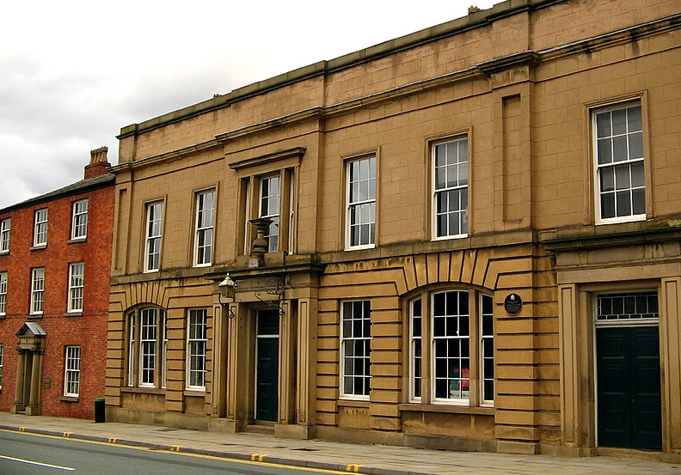

Liverpool Road station in Manchester. This was the original terminus of the Liverpool and Manchester Railway, and is now part of the Manchester Museum of Science and Industry. The photograph has been released into the public domain by its author, G-Man (https://www.g-man.net/).

**Manchester Oxford Road**

The station was built and opened in 1849 as the main Manchester station and headquarters of the Manchester South Junction and Altrincham Railway (MSJ&AR), which was incorporated in July 1845. It operated an 8.5 mile (14 km) route between Altrincham in Cheshire and Manchester London Road railway station (now Piccadilly) in Manchester. The MSJ&AR line operated with three different systems of electrification within a period of about 60 years. The fast, frequent service resulting from the introduction of the first generation of electric trains in 1931 was a significant contributor to suburban development in the Stretford, Sale and Altrincham districts, south-west of Manchester. The southern part of the MSJ&AR's route has been part of the Manchester Metrolink light rail system since 1992. The northern section between Manchester Piccadilly and Deansgate stations is now an intensively-used section of the National Rail network, used by trains running north and west of Manchester.

The MSJ&AR's original station at Deansgate was called Knott Mill and Deansgate, opened in 1849 on Hewitt Street, but was enlarged and rebuilt in 1896 in its current location. Deansgate station is linked by a footbridge to the Metrolink station called G-Mex, serving the Manchester Exhibition and Event Centre, which takes the old MSJ&AR to Altrincham as a light rail system.

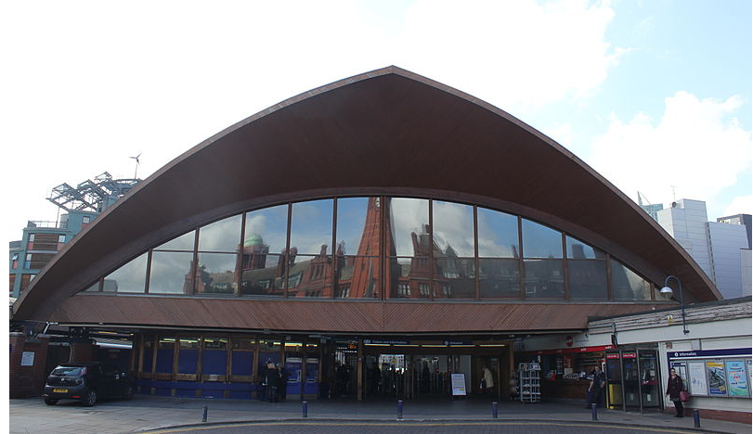

The current main entrance to Manchester Oxford Road station. The station sits on a Grade II listed viaduct, which was built in 1839 as part of the Manchester, South Junction and Altrincham Railway. To reduce load on this viaduct, the station unusually utilises laminated wood structures as opposed to masonry, concrete, iron or steel. English Heritage describes it as a "building of outstanding architectural quality and technological interest; one of the most dramatic stations in England". It was Grade II listed in 1995. Architectural critic Nikolaus Pevsner described the station as "one of the most remarkable and unusual stations in the country". Photograph by Patyo1994, copied under the Creative Commons Attribution-Share Alike 4.0 International licence.

**Manchester Piccadilly**

Manchester Piccadilly is the principal railway station in [Manchester](https://en.wikipedia.org/wiki/Manchester). It was opened as Store Street in 1842, it was renamed Manchester London Road in 1847 and became Manchester Piccadilly in 1960. It was originally shared between the Manchester and Birmingham Railway (M&BR), which with other amalgamations became the London and North Western Railway (LNWR), and the Sheffield, Ashton-under-Lyne and Manchester Railway (SA&MR), which again with other amalgamations became the Great Central Railway (GCR). Relations between the two companies were usually hostile because of the GCR's independent competing route to London, so they had their own booking offices and facilities, and in day-to-day matters preferred to have as little to do with each other as possible. Nevertheless they co-operated in extending and rebuilding the station a number of times because of expanding traffic. LNWR traffic used the southern platforms and ran mainly southwards towards Birmingham and their London terminus at Euston, but also north eastwards towards Huddersfield and Leeds. GCR traffic used the northern platforms and ran predominantly eastwards towards Sheffield and Lincoln and also operated a route to their own London terminus at Marylebone.

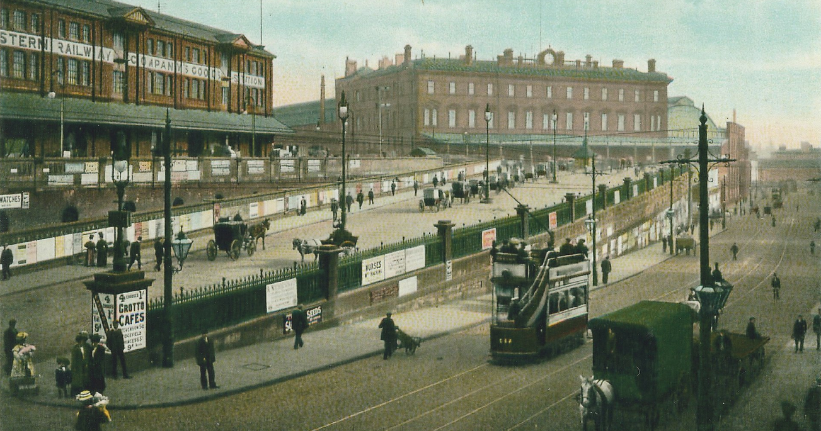

Colourised postcard of the frontage of London Road station c. 1905. Author unknown (public domain).

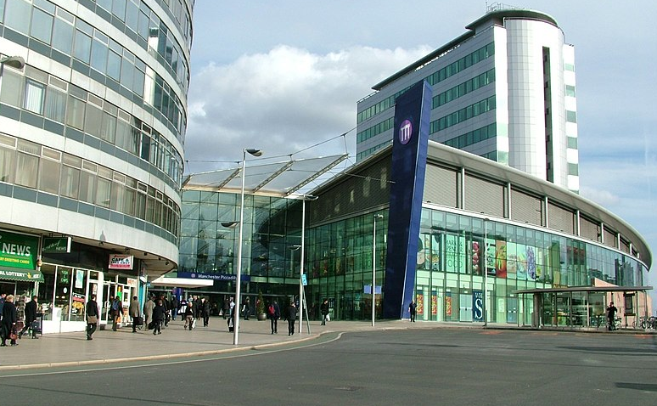

Manchester Piccadilly station approach - April 11 2005. Photograph by Tagishsimon, copied under the Creative Commons Attribution-Share Alike 3.0 Unported licence

**Manchester Victoria**

Manchester Victoria station is a combined mainline railway station and Metrolink tram stop. Situated to the north of the city centre on Hunts Bank, close to Manchester Cathedral, it adjoins Manchester Arena which was constructed on part of the former station site in the 1990s. It was opened in 1844 by the Manchester and Leeds Railway (M&LR), which was founded in 1836 and began building its line between Manchester and Leeds in 1837. Originally its line terminated at Manchester Oldham Road, which opened on 3 July 1839. The company realised it would be advantageous to join its line to the Liverpool and Manchester Railway (L&MR), creating a through route from Liverpool to Yorkshire with a joint station serving the centre of Manchester. The M&LR built an extension from Miles Platting to the station which opened on 1 January 1844. On this date, the Oldham Road terminus was closed to passenger services and became a goods station. The new station had a 852 ft (260 m) long single platform which handled M&LR trains to Leeds and elsewhere at its eastern end. The L&MR extended its line from Ordsall to Victoria and its trains operated from the western end from 4 May 1844, on which date its Liverpool Road station terminus became a goods station.

The L&MR became part of the Grand Junction Railway in 1845, which in turn amalgamated with other railways to create the London and North Western Railway (LNWR) in 1846; the M&LR amalgamated with other railways to create the Lancashire and Yorkshire Railway (L&YR) the following year. The headquarters of the L&YR were based alongside Victoria.

In 2009, Victoria was voted the worst regional interchange station in the United Kingdom! The station underwent a two-year £44 million modernisation programme which was completed in August 2015. Renovation entailed electrification of lines through the station, renewed Metrolink stop with an additional platform, restoration of listed features, upgraded retail units, and a new roof.

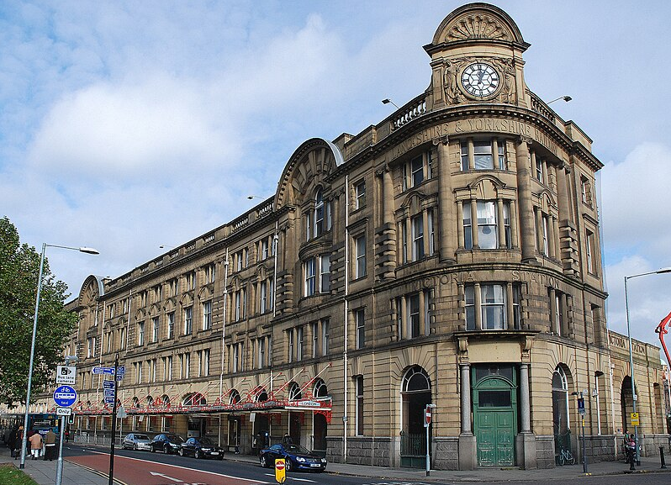

Manchester Victoria Station in 2009. Respect for railway heritage ensured that the modernisation programme left this magnificent exterior and much of the original building interior intact. Photograph by Paul Hermans (http://www.hermanstudios.com/), copied under the GNU Free Documentation Licence.

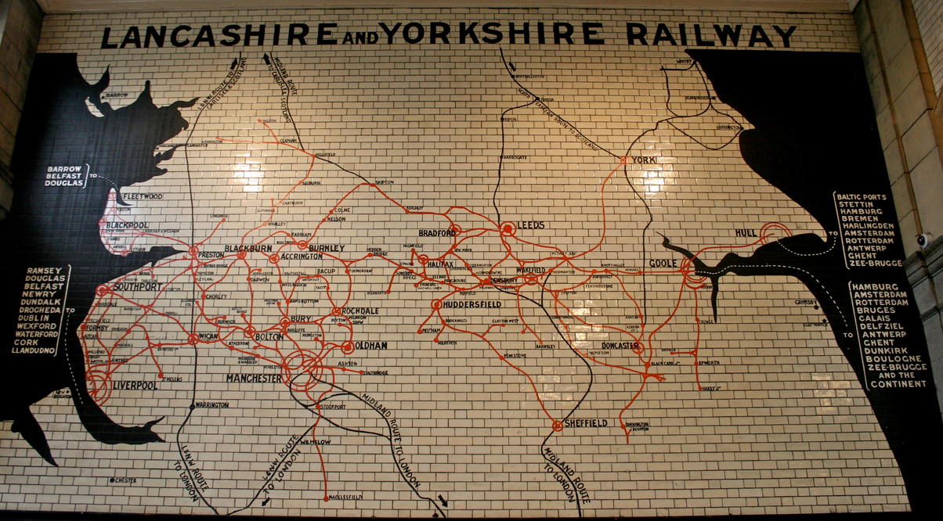

A map of the former Lancashire and Yorkshire Railway on a wall of Manchester Victoria Station and still in place though much cleaner than it was. Photograph by Mike Peel (https://www.mikepeel.net/). Copied under the Creative Commons Attribution-Share Alike 4.0 International licence.

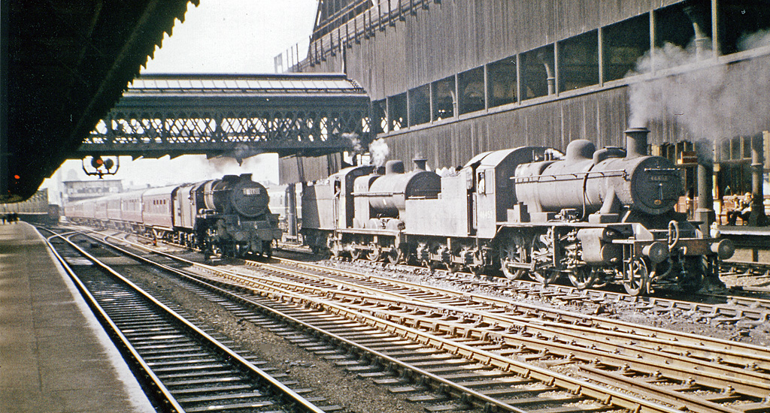

View westwards in 1964 from the long through platform 11/3 (Manchester Victoria platform 11 and Manchester Exchange platform 3. Prior to the rebuild these stations were adjacent and linked together by this platform). An eastbound express, with the typical Stanier Class 5 4-6-0, is charging from Exchange through towards Yorkshire without banker, while an LMS Ivatt 2MT 2-6-0 and a 4F 0-6-0 wait to bank other trains up the notoriously heavy gradient to Miles Platting Junction. © Copyright Ben Brooksbank and licensed for reuse under the Creative Commons Attribution Share-alike licence 2.0

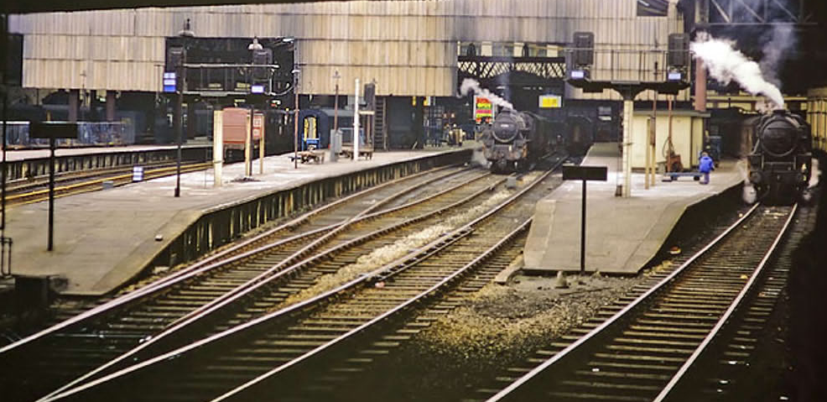

Manchester Victoria's bay platforms 6–10 in 1968. Only the two on the right still exist. This is the old Manchester Victoria that I (Albert) very fondly remember from my trainspotting days - dark, gloomy, noisy and dirty - paradise! Photographed by Robin Webster (https://www.robinwebsterdop.com/), licensed for reuse under the Creative Commons Attribution-ShareAlike 2.0 licence.

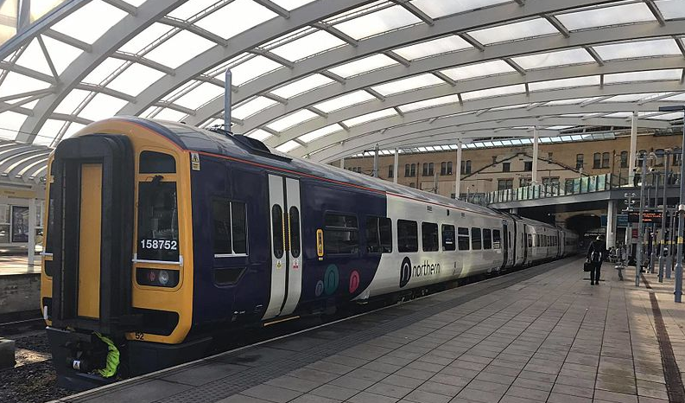

Interior of the modernised Manchester Victoria photographed by Rcsprinter123 in 2016 and copied under the Creative Commons Attribution 3.0 Unported licence.

**Manchester Central**

Although closed in 1969 and therefore not featured in the simulation this station deserves mention because of its historic importance as the Midland Railway's Manchester terminus for its services to London St Pancras.

The station was built between 1875 and 1880 by the Cheshire Lines Committee (CLC), and was officially opened on 1 July 1880. The CLC was a joint enterprise between the Great Northern Railway (GNR), the Manchester, Sheffield and Lincoln Railway (MS&LR) - which became the Great Central Railway (GCR), and the Midland Railway (MR).

The Midland Railway used Manchester Central as its terminus for services including express trains to London St Pancras. Beginning in 1938, the London, Midland and Scottish Railway (successor to the MR) ran two prestige expresses, The Peaks and the Palatine, stopping at Chinley, Millers Dale, Matlock, Derby and Leicester. Between 1960 and 15 April 1966, during the electrification of the West Coast Main Line, Central Station was the terminus for the Midland Pullman, a streamlined blue six-coach diesel multiple unit. This stopped at Cheadle Heath (now closed), before running fast to St Pancras.

Services through Millers Dale finished in July 1968, when the line was closed as a through route. The station provided local services to Chester and Liverpool, but closed to passengers on 5 May 1969, when the remaining services were transferred to Manchester Oxford Road and Manchester Piccadilly stations.

Over a decade, Central Station fell into a dilapidated state, was damaged by fire and was used as a car park. The property was acquired by Greater Manchester Council and, in 1982, work began on converting it into an exhibition centre, which opened in 1986 as the Greater Manchester Exhibition and Conference Centre or G-Mex. It was subsequently renamed Manchester Central, in honour of its railway history.

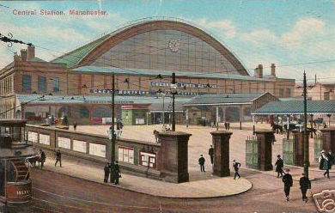

Manchester Central Station from a postcard circa 1905 (public domain).

**Salford Central**

Salford Central station opened on 29 May 1838 as a terminus of the Manchester and Bolton Railway and was originally named Salford. In 1843, a connection to Manchester Victoria was built, carried on iron columns. To avoid confusion with the newly built Salford Crescent station, in 1988 it was renamed Salford Central. With only platforms 1 and 2 currently in use (platforms 3 and 4 have been disused since the early 1990s), the station is now managed by Northern Trains and has undergone a major transformation involving construction of a new ticket office as well as making the station building fully accessible by the use of ramps from the entrances to the ticket office and lifts and ramps from the ticket office to the platforms.

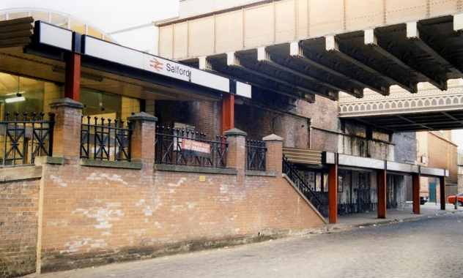

Salford Central station building 1989 prior to refurbishment and renaming. Salford station was normally a ghost station outside Monday to Friday rush hours, being rather marooned in a sea of urban dereliction. Quite a lot has changed in this part of Salford since 1989. Photographed by Peter Whatley and copied under the Creative Commons Attribution-ShareAlike 2.0 licence.

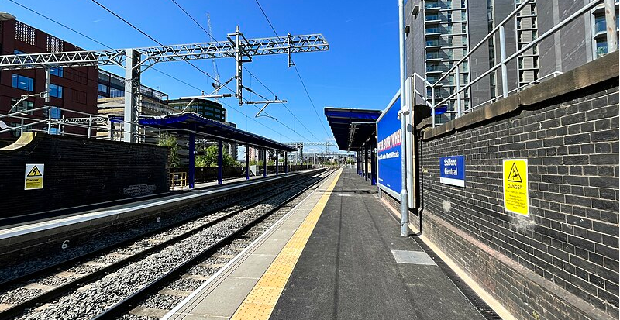

A view of Salford Central platforms in 2023 after the refurbishment. Photographed by Mcnivenjmichael and copied under the Creative Commons Attribution-Share Alike 4.0 International licence.

**Salford Crescent**

The station consists of a single island platform with a ticket office and waiting room. The station was opened in 1987 and is located near to the University of Salford, between the Peel Park and Frederick Road Campus.

Salford Crescent is the point of a split in the Manchester–Preston line, with local services running on to Manchester Victoria and long-distance services going to Manchester Piccadilly (via the 1988 Windsor Link to Ordsall Lane Junction), and is also part of the line between Manchester and Southport, frequently being used as an interchange between the two lines. Manchester North signalling centre was formerly located at the station, prior to its closure in April 2015.

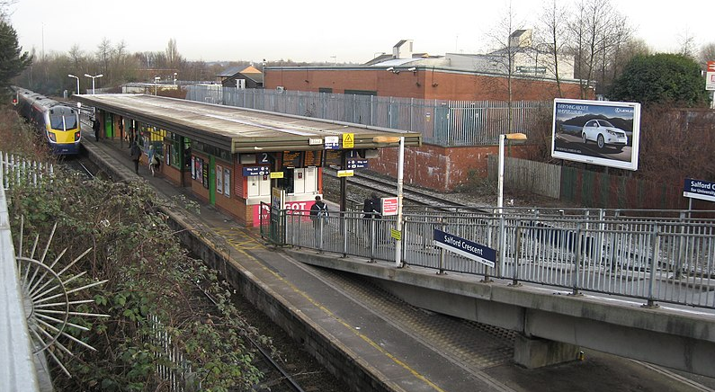

Salford Crescent Railway Station photographed by Richard Rogerson (https://www.richardrogerson.com/) in 2010 and copied under the Creative Commons Attribution-Share Alike 2.0 Generic licence.

**Modern track extensions**

Two important short links have been constructed that greatly facilitate train movements in the area. The first was the Winsor Link, a 700-metre railway line that connects Salford Crescent and Manchester Deansgate stations. It was opened by British Rail in May 1988, and came into full use in 1989. This link allows services from the Manchester–Preston line and the Manchester–Southport line, from the north-west of Manchester (such as from Southport via Wigan Wallgate and Bolton, also from Blackpool North and Lancaster via Preston) to directly access Manchester Piccadilly station: Before the link was opened, services from these lines could only run into Manchester Victoria, although indirect access for services from Wigan or Preston to Manchester Piccadilly had been possible via the West Coast Main Line's connection to the Chat Moss route; the northern route of the Liverpool-Manchester lines.

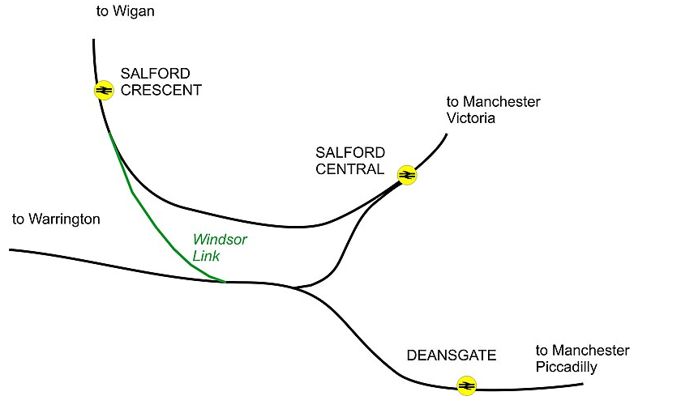

The Windsor Link railway line in Greater Manchester by Crookesmoor and copied under the Creative Commons Attribution-Share Alike 3.0 Unported licence.

The second is the Ordsall Chord, connecting Victoria to Oxford Road and Piccadilly. By the late 20th century, the rail network in Manchester could not support demand. The main stations at Piccadilly and Victoria were not linked and many trains terminated at Victoria taking up excessive platform space. One solution, the Picc-Vic tunnel between the stations, was proposed in the 1970s but rejected on cost grounds in 1977.

A curve at Ordsall linking Piccadilly to Victoria was proposed in the late 1970s when it was known as the Castlefield Curve after the nearby district. It was designed to increase capacity and reduce journey times into and through Manchester. It allows trains to run from Leeds, Newcastle and Redcar Central direct to Manchester Airport. It became operational on 10 December 2017.

Very sadly the chord cut the L&MR's original station at Liverpool Road off from the national network. There was much soul searching about this at the time with loud and forceful protests from lovers of railway history. The Museum of Science and Industry had used the link to bring rolling stock into and out of the museum but now has to use much less convenient road transport. Eventually current needs overrode historic concerns.

The original intention was for the chord to be part of a more extensive upgrade involving two new through platforms at Piccadilly, three new platforms at Salford Central, and Oxford Road to be remodelled. However these further developments have not yet taken place so the chord's use is limited by the continuing limited capacity at Victoria, Oxford Road and Piccadilly.

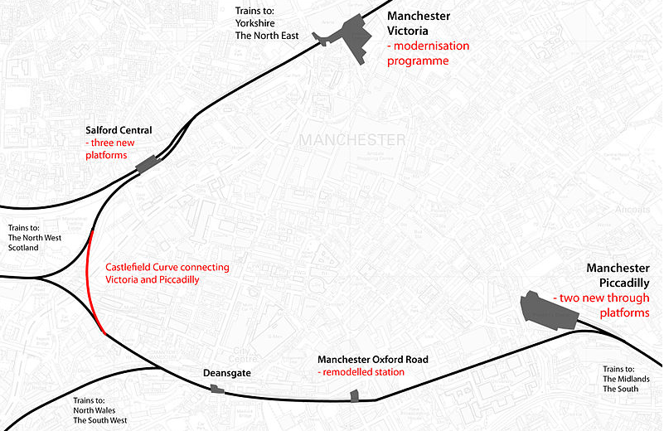

Schematic maps showing rail improvements through Manchester as part of the Northern Hub scheme (including the Ordsall Chord, also known as the Castlefield Curve, marked in red) Author Stevo1000, copied under the Creative Commons Attribution-Share Alike 3.0 Unported license.

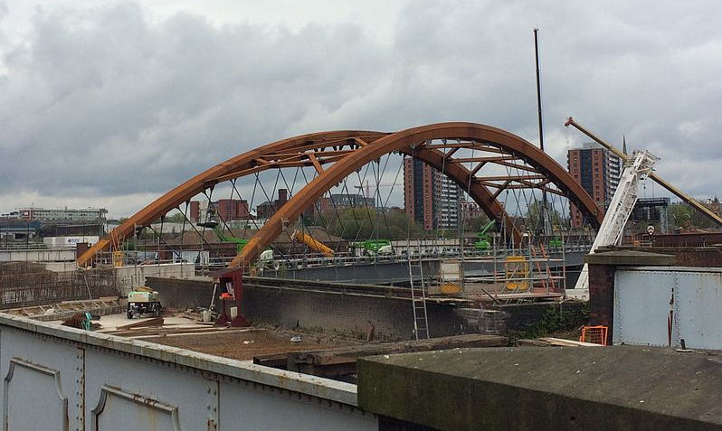

Ordsall Chord under construction in April 2017, photographed by Delusion23 and copied under the Creative Commons Attribution-Share Alike 4.0 International licence.

**Acknowledgements:**

https://en.wikipedia.org/wiki/Liverpool_and_Manchester_Railway

https://en.wikipedia.org/wiki/Manchester_Liverpool_Road_railway_station

https://en.wikipedia.org/wiki/Manchester,_South_Junction_and_Altrincham_Railway https://en.wikipedia.org/wiki/Manchester_Oxford_Road_railway_station

https://en.wikipedia.org/wiki/Manchester_Piccadilly_station

https://en.wikipedia.org/wiki/Manchester_Victoria_station

https://en.wikipedia.org/wiki/Manchester_Central_railway_station

https://en.wikipedia.org/wiki/Cheshire_Lines_Committee

https://en.wikipedia.org/wiki/Salford_Central_railway_station

https://en.wikipedia.org/wiki/Salford_Crescent_railway_station

https://en.wikipedia.org/wiki/Windsor_Link_Line,_Salford

https://en.wikipedia.org/wiki/Ordsall_Chord

Pre-grouping route railway information taken from: https://www.railmaponline.com/UKIEMap.php

Liverpool and Manchester Railway Atlas by Joe Brown, Crecy Publishing Ltd.